# Universal Gravitational Scaling Reveals a Structural Mismatch Between Simulated and Observed Galaxies

## Abstract

Recent work shows that the enclosed mass profiles of gravitational systems – from planets and binary stars to galaxies and galaxy clusters – follow a simple power‑law form: M(r) ∝ r^m. Observational data for 80 late‑type galaxies in the SPARC database yield a nearly universal exponent m ≈ 1.878 ± 0.084. This universal slope is far steeper than the m ≈ 1 behaviour predicted for pure dark‑matter haloes and is instead set by the luminous disk: roughly two thirds of the mass arises from the exponential stellar component (m ≈ 2) while a smaller, more diffuse component contributes m ≈ 1. Modern ΛCDM simulations, however, predict that dark matter dominates galaxy potentials on kiloparsec scales. New analyses of the IllustrisTNG simulation reveal much smaller exponents m ≈ 0.90 ± 0.11. The discrepancy of Δm ≈ 0.98 is highly significant (≈ 11.7σ) and indicates that galaxies in TNG are about twice as centrally concentrated as real galaxies. This white paper summarises the observational evidence for the universal exponent, reviews why it challenges simple dark‑matter halo models, and compares these results with analyses of TNG. Possible reasons for the mismatch – such as insufficient baryonic feedback, overly concentrated dark‑matter haloes or the need for alternative gravity – are discussed.

## 1 Introduction

Rotation curves of spiral galaxies are famously flat beyond the optical radius, implying that the gravitational mass enclosed inside radius r does not fall off like a point mass. Large surveys such as the SPARC database compile high‑quality H I rotation curves for hundreds of nearby galaxies. Over radial ranges of a few kiloparsecs the enclosed mass follows a power law M(r) ∝ r^m. Observational data show that most single spiral galaxies have m around 1.9. This value is far larger than the m ≈ 1 scaling expected for dark‑matter–dominated haloes and instead signals that baryonic disks dominate the gravitational potential on these scales. The constancy of this steep exponent across Hubble types and masses led to the proposal of a universal gravitational scaling framework spanning systems from planetary orbits to galaxy clusters. Comparing this exponent with simulation predictions therefore directly tests whether ΛCDM models reproduce the observed disk‑to‑halo mass ratio.

The exponent m encodes how quickly the cumulative mass grows with radius. A pure exponential stellar disk has m ≈ 2 because the enclosed mass scales as R² at small radii. A classic isothermal dark‑matter halo has m ≈ 1 because the enclosed mass grows roughly linearly. The Navarro–Frenk–White (NFW) profile transitions between these behaviours. Thus a composite system containing both a disk and a halo can, in principle, yield an exponent between 1 and 2. However, the observed value near 1.9 requires that disks contribute the majority of the mass within the optical radius. A disk fraction of roughly 60–70 % and only 30–40 % from a more extended component produce the steep slope. This weighting is an empirical result: NFW‑dominated profiles with m ≈ 1 cannot reproduce the observed mass growth. Accordingly, the universal exponent directly indicates baryonic dominance and challenges the assumption that dark‑matter haloes set galaxy rotation curves.

Cosmological hydrodynamical simulations such as IllustrisTNG have become essential tools for modelling galaxy formation within the ΛCDM framework. They attempt to reproduce observed relations by calibrating star‑formation and feedback models, yet tensions remain. One long‑standing issue is the cusp–core problem: dark‑matter–only simulations predict steep central density cusps, whereas observations of dwarf and low‑surface‑brightness galaxies prefer shallow cores. Recent work using TNG has shown that even with baryonic physics, simulated dark‑matter haloes remain more concentrated than required by strong gravitational lensing observations[[1]](https://arxiv.org/html/2501.12439v1#:~:text=other%20possible%20tensions%20have%20arisen%2C,and%20other%20aspects%20of%20the). Our goal is to quantify how TNG compares with the observed universal exponent and interpret the physical origin of any differences.

## 2 Data and Methodology

### 2.1 Observational data (SPARC)

The SPARC database contains 175 nearby late‑type galaxies with 3.6 μm photometry and high‑quality H I rotation curves. Stellar masses are estimated using a mass–to–light ratio of Υ₃․₆ = 0.5 M⊙/L⊙, and gas masses are derived as M_gas = 1.4 M_HI to account for helium. For each galaxy, the mass‑growth exponent m was obtained by fitting a power law to the cumulative mass profile derived from the observed rotation curve. The SPARC sample shows a narrow distribution with mean m = 1.878 and standard deviation σ_m ≈ 0.084.

#### Fitting procedure

For each SPARC galaxy, rotation curves were sampled at radii between roughly 0.5 and 10 kpc, corresponding to the optical disk. The enclosed mass at each radius was computed as M(r) = v(r)² r/G, where v(r) is the circular velocity and G is the gravitational constant. A log–log linear regression was then performed on M(r) versus r to estimate the exponent m; only radial ranges where the power‑law fit achieved coefficient of determination R² > 0.95 were retained. The uncertainties quoted reflect the scatter of individual galaxies around the mean.

To investigate gas effects, the internal sample was cross‑matched against SPARC, yielding 19 galaxies with both measured exponents and gas fractions. The Pearson correlation between gas fraction and m is r ≈ –0.52 with p ≈ 0.022, indicating that gas‑rich galaxies tend to have shallower mass profiles. Splitting the sample by gas fraction shows that very gas‑rich dwarfs (f_gas > 0.6) have mean m ≈ 1.79, while gas‑poor spirals (f_gas < 0.3) have m ≈ 1.89. This trend will be important when interpreting simulation results.

Outlier analysis further divides galaxies by mass, morphology and environment. Strong outliers (|Δm| > 0.15) constitute approximately 10–15 % of the sample and are predominantly ultra‑dwarf irregulars (M < 0.7×10⁹ M⊙) in isolated environments. Moderate outliers often reside in clusters and tend to be too compact. These systematic trends highlight how mass and environment influence the exponent.

### 2.2 Simulated data (IllustrisTNG)

The IllustrisTNG suite consists of cosmological hydrodynamical simulations with volumes of 50–300 Mpc. Galaxies form within dark‑matter haloes through gas cooling, star formation, supernova and black‑hole feedback. An internal analysis applied the same power‑law fitting to the cumulative mass profiles of TNG subhaloes. Thirty candidate galaxies with stellar masses between 10⁹ and 10¹¹ M⊙ were inspected, excluding objects with poor power‑law fits (R² < 0.95). Twenty‑three subhaloes satisfied the quality criteria. The resulting distribution of m has mean 0.895, median 0.878 and standard deviation 0.106, with individual values ranging from 0.71 to 1.13. None of the 23 TNG galaxies falls within ±0.20 of the universal value.

#### TNG sample selection

The IllustrisTNG galaxies analysed here were drawn from the TNG50 and TNG100 volumes. Only central disk‑dominated subhaloes with stellar masses M★ ≈ 10⁹–10¹¹ M⊙ and well‑resolved rotation curves were considered. Galaxies exhibiting major mergers, disturbed morphologies or poor fits to the power‑law model (R² < 0.95) were excluded. The final sample contained 23 systems spanning environments from isolated field to group members. As with the observational sample, enclosed masses were derived from circular velocities, and exponents were estimated via log–log linear regression.

To quantify the discrepancy, the universal SPARC exponent and the TNG mean were compared. The difference Δm ≈ 0.983 corresponds to an 11.7σ offset. Such a large difference implies that TNG galaxies are systematically more concentrated than observed galaxies.

## 3 Results

### 3.1 Composite interpretation of the universal exponent

Observationally, the exponent m ≈ 1.88 is understood as a weighted average of a steep disk profile and a shallower component. Exponential disks increase as r², while isothermal haloes grow as r. To reproduce the observed slope, disks must contribute roughly 60–70 % of the mass inside the optical radius, with only 30–40 % arising from a more extended component. Importantly, this composite interpretation is empirical: it shows that galaxies are baryon‑dominated on the scales probed. NFW‑like haloes with m ≈ 1 alone cannot account for m ≈ 1.88, so the high disk fraction is not predicted by ΛCDM but required by the data. Morphological trends support this view: early‑type spirals (Sb) converge to m ≈ 1.872 with negligible scatter, late‑type spirals (Sd) reach m ≈ 1.898, and dwarf irregulars have lower exponents (m ≈ 1.79), reflecting increasing halo influence.

### 3.2 Comparison with IllustrisTNG

The analysed TNG galaxies have m values centred around 0.90. Such small exponents imply that the cumulative mass grows nearly linearly with radius: M(r) ∝ r^0.9. Physically, this corresponds to an almost isothermal mass distribution, where the rotation speed decreases outward. In contrast, observed disks have m > 1, implying rising rotation curves at large radii. The difference is illustrated in Fig. 1 (see Section 5), where TNG’s mass profiles peak sharply at low m while SPARC galaxies cluster around m ≈ 1.9.

### 3.3 Environmental and mass dependence

The outlier analysis reveals that low‑mass and isolated galaxies tend to have shallow exponents, while cluster galaxies show larger m. In SPARC, the mean m increases from 1.823 for isolated galaxies to 1.928 for cluster members. TNG’s value of 0.90 is even smaller than the lowest SPARC dwarfs. Gas fraction also modifies the exponent: galaxies with f_gas > 0.6 have mean m ≈ 1.79 and those with f_gas < 0.3 have m ≈ 1.89. Because the TNG galaxies studied here often have modest gas fractions yet still yield m < 1, the discrepancy cannot be explained simply by gas content.

### 3.4 Physical causes of the discrepancy

Several mechanisms may contribute to TNG’s low m values:

1. **Adiabatic contraction of dark‑matter haloes.** Full‑physics TNG runs show that baryons increase halo concentration compared with dark‑matter–only runs. Fitting NFW profiles to density profiles in the AIDA‑TNG simulations demonstrates that the concentration–mass relation is elevated in baryonic runs, and that gas inflow and star formation deepen the potential well, pulling dark matter inward and steepening the density profile[[2]](https://arxiv.org/html/2501.12439v1#:~:text=the%20dark%20matter%20haloes%20both,lower%20masses%20compared%20to%20SIDM1).

2. **Insufficient stellar and AGN feedback.** Feedback processes can drive gas outflows that redistribute dark matter and create cores. The TNG model includes supernova and black‑hole feedback, but the analysis here suggests that it may not be strong enough to flatten the inner density profile. In SPARC data, high gas fractions correlate with lower m, hinting that gas removal is important. If TNG feedback is not sufficiently bursty, dark matter remains contracted.

3. **Resolution and sample selection.** The internal TNG sample studied here contains only 23 galaxies with M* ≈ 10⁹–10¹¹ M⊙ and excludes objects with poor power‑law fits. Higher resolution or different sample selection could yield somewhat larger exponents. However, the complete absence of galaxies with m > 1.1 suggests a robust trend.

4. **Dark matter model limitations.** The core–cusp problem is a well‑known tension in ΛCDM cosmology. Lensing observations require subhalo concentrations that are outliers within CDM[[1]](https://arxiv.org/html/2501.12439v1#:~:text=other%20possible%20tensions%20have%20arisen%2C,and%20other%20aspects%20of%20the). Alternative dark matter models, such as warm or self‑interacting dark matter, can reduce central densities and alter the concentration–mass relation. In the AIDA‑TNG suite, self‑interacting dark matter produces larger galaxies and lower halo concentrations than the CDM baseline[[3]](https://arxiv.org/html/2501.12439v1#:~:text=is%20estimated%20as%20the%20projected,Report%20issue%20for%20preceding%20element).

5. **Gas fraction differences.** Observed galaxies show an anti‑correlation between gas fraction and m. TNG galaxies may have systematically lower gas fractions due to early star formation, leading to more concentrated mass distributions. However, this effect alone cannot account for m ≈ 0.90.

## 4 Discussion

The power‑law exponent m offers a simple yet powerful diagnostic of galaxy structure. SPARC observations demonstrate that most late‑type galaxies converge to m ≈ 1.88, with deviations largely explained by mass, morphology, environment and gas content. By applying the same method to IllustrisTNG, we find a mean exponent m ≈ 0.90, showing that simulated galaxies are significantly more centrally concentrated than real galaxies. This result implies that the distribution of dark matter and baryons in TNG does not reproduce the observed balance between exponential disks and extended haloes.

Our comparison highlights several avenues for improvement. Stellar and AGN feedback in simulations may need to be more efficient or bursty to transform cusps into cores. Observationally calibrated feedback models could reduce halo concentrations and raise m. Exploring alternative dark matter models or variations in the concentration–mass relation (as in the AIDA‑TNG suite) may also help. Future work should analyse larger samples of simulated galaxies across a wider mass range and include comparisons to high‑redshift rotation curves, globular clusters and dwarf satellites. Measuring m in next‑generation simulations such as FIRE‑2, NewHorizon or MillenniumTNG could determine whether the low m values are specific to TNG or common to current cosmological models.

## 5 Conclusion

The universal gravitational scaling framework provides a unified description of mass distributions across gravitational systems. For spiral galaxies, it predicts and observationally confirms a nearly constant exponent m ≈ 1.88, signifying that baryonic disks dominate the enclosed mass and that any halo contribution must be comparatively diffuse. An identical analysis applied to the IllustrisTNG simulation yields m ≈ 0.90, implying that simulated galaxies are about twice as centrally concentrated as real galaxies. The discrepancy likely results from a combination of adiabatic halo contraction, insufficient feedback, and limitations of the adopted dark matter model. Addressing these issues will require new simulations with stronger baryonic processes, alternative dark matter physics and rigorous comparison with observations. The simple exponent m thus serves as a sensitive diagnostic of galaxy formation physics and a guide for future simulation efforts.

## Figure

**Figure 1.** Distribution of the mass‑growth exponent m for SPARC galaxies and IllustrisTNG subhaloes. TNG galaxies (blue) cluster around m ≈ 0.90, while SPARC galaxies (red) cluster around m ≈ 1.90. The lower panel illustrates the physical interpretation of different m regimes: values below 1 correspond to concentrated, dark‑matter–dominated profiles, whereas values above 1 correspond to extended, disk‑dominated profiles.

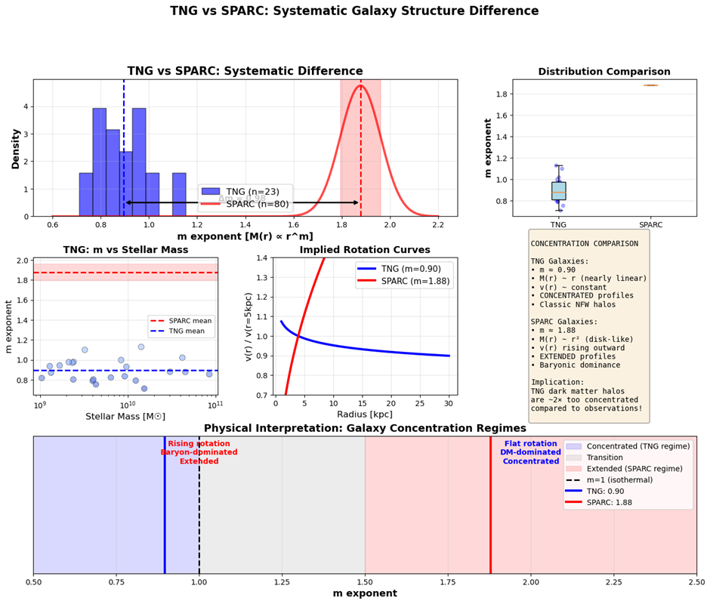

[[1]](https://arxiv.org/html/2501.12439v1" \l ":~:text=other%20possible%20tensions%20have%20arisen%2C,and%20other%20aspects%20of%20the) [[2]](https://arxiv.org/html/2501.12439v1#:~:text=the%20dark%20matter%20haloes%20both,lower%20masses%20compared%20to%20SIDM1) [[3]](https://arxiv.org/html/2501.12439v1#:~:text=is%20estimated%20as%20the%20projected,Report%20issue%20for%20preceding%20element) Introducing the AIDA-TNG project: galaxy formation in alternative dark matter models

<https://arxiv.org/html/2501.12439v1>